Implementation of SINCH as a VoIP provider for Enterprise Alert

If you want to use SINCH (www.sinch.com) as a VoIP provider in an EA VoIP communication channel, please do the following steps:

Login to www.sinch.com and sign up for a new account:

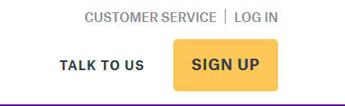
On the next page select “Create an Account” for Voice, Video, Verification
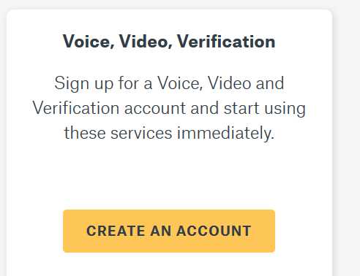
Put in your account details and your password, agree to the terms and conditions and check, that you are no robot. Press CREATE A NEW ACCOUNT
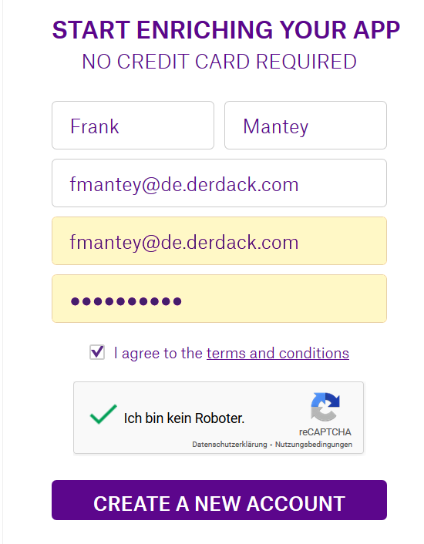
Then you will be directed to your SINCH portal.

Outbound calls

For outbound calls you must go to Apps and CREATE NEW APP.
Give it a proper name and description and press CREATE APP
The click on the name of your newly created app. Under “Credentials & Info” you will find Key and Secret which is needed for the Credentials in the VoIP Channel in Enterprise Alert.

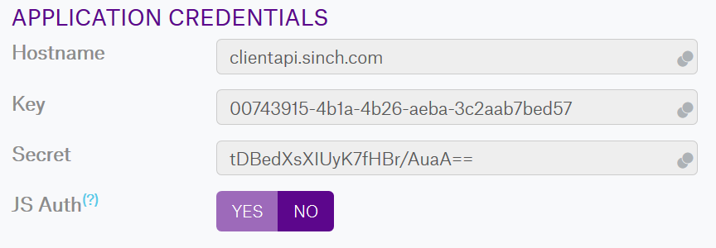
In the VoIP channel in Enterprise Alert you should the Key as the “Account Name or SIP URI” and the Secret as the password

SINCH has multiple geographical regions which can be used to configure the SIP infrastructure:

Europe:
euc1.sip.sinch.com
North America:
use1.sip.sinch.com
South America:
sae1.sip.sinch.com
Southeast Asia:
apse1.sip.sinch.com
Australia:
apse2.sip.sinch.com
For our test we have used the European SIP endpoint.
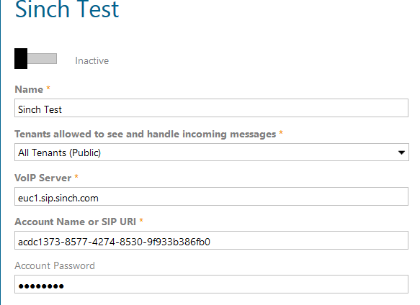

Inbound calls

If you want to be able to call Enterprise Alert you need at first to rent a telephone number from SINCH.
In your SINCH portal go to Numbers and press

The problem here is that in some countries you have to register for a number and in some not. The following excel sheet give you an overview:

In column F you will find the “Registration Type”. This shows you what information is needed for the countries that require registration.

If you have finally you phone number from SINCH you need to create a new App in your SINCH portal.
In this new app you have to go to “Voice And Video”.
There you set the Connect calls to “SIP Forwarding” and enter the SIP URI

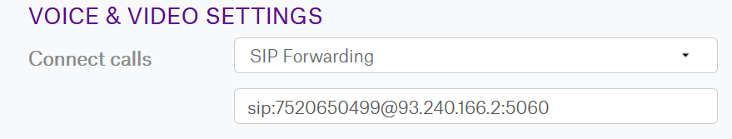

In our test the rented phone number is +44 7520 650499 and the IP 93.240.166.2 is the Derdack Public IP address.

In the EA VoIP channel, you have to set
- SIP Transport = UDP
- RTP port range used: 10000 – 20000

Also, it is needed to whitelist all of the following IP addresses
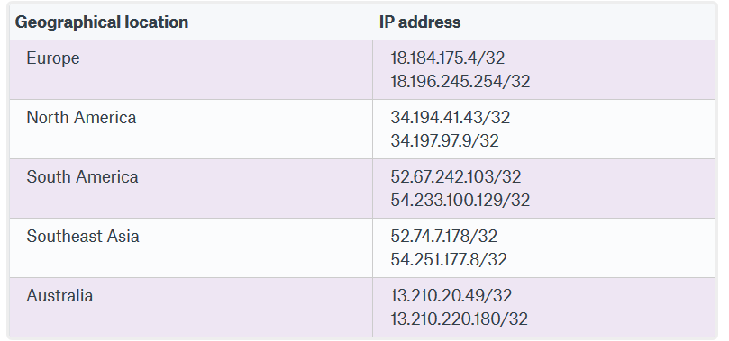

More details can be found on the following link:

https://developers.sinch.com/docs/voice-sip-trunking

